Investing a Percentage of Your Income (II) - Corrected Full Answer

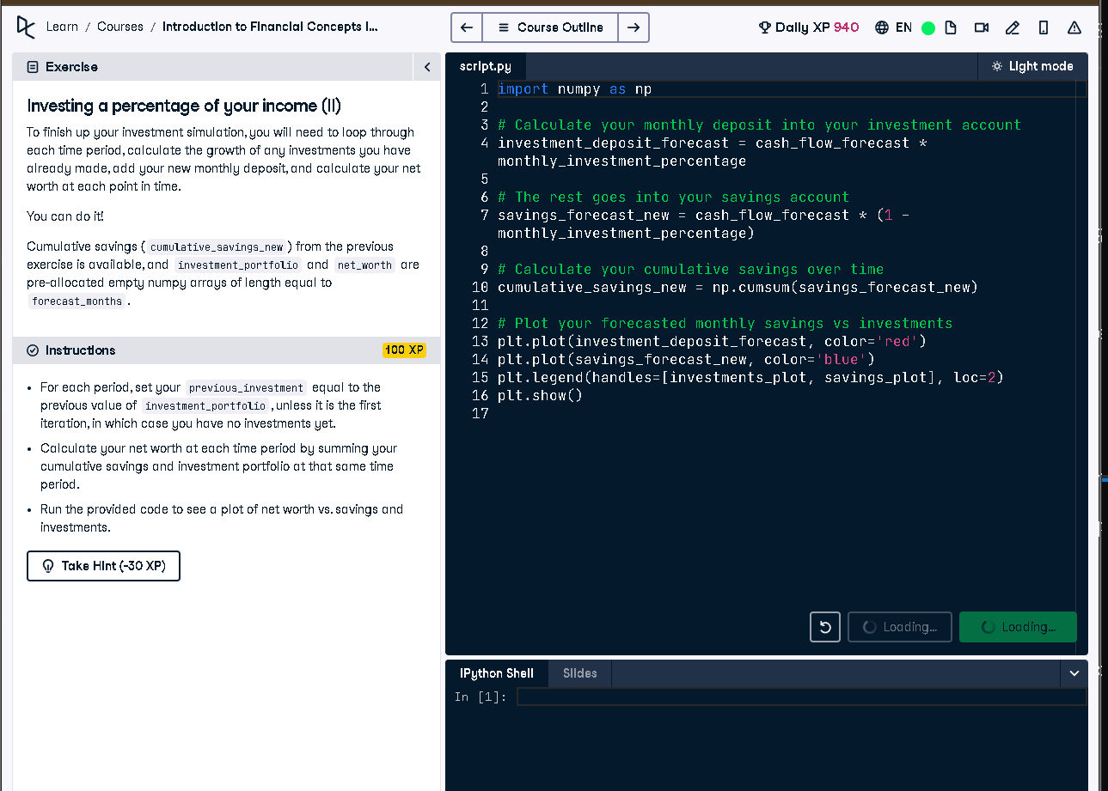

# Full Code Answer:

import numpy as np  
  
# Loop through each forecast period  
for i in range(forecast_months):  
   
 # Find the previous investment deposit amount  
 if i == 0:   
 previous_investment = 0  
 else:  
 previous_investment = investment_portfolio[i-1]  
   
 # Calculate the value of your previous investments, which have grown  
 previous_investment_growth = previous_investment*(1 + investment_rate_monthly)  
   
 # Add your new deposit to your investment portfolio  
 investment_portfolio[i] = previous_investment_growth + investment_deposit_forecast[i]  
   
 # Calculate your net worth at each point in time  
 net_worth[i] = investment_portfolio[i] + cumulative_savings_new[i]  
   
# Plot your forecasted cumulative savings vs investments and net worth  
plot_investments(investment_portfolio, cumulative_savings_new, net_worth)

# Question:

How do you compute net worth over time by combining investment growth with savings deposits each forecast period?

# 20-word Explanation (Question):

Net worth calculation includes cumulative savings plus investment portfolio growth, updated monthly for accurate financial forecasting.

# Answer:

Each month, grow previous investments by monthly rate, add new deposits, then sum with cumulative savings for net worth.

# 20-word Explanation (Answer):

We simulate monthly compounding on investments and add cash deposits, then combine with savings to track net worth.